**Task 1:** Retrieve name, continent and region columns from the country table.

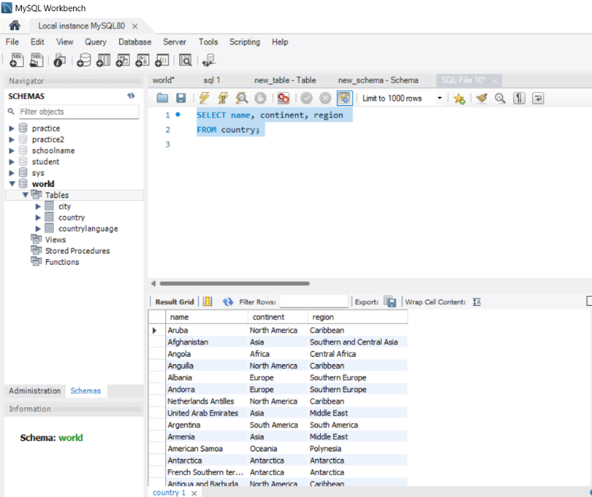

**Task 2:** Retrieve all the countries whose name starts with the letter 'A'.

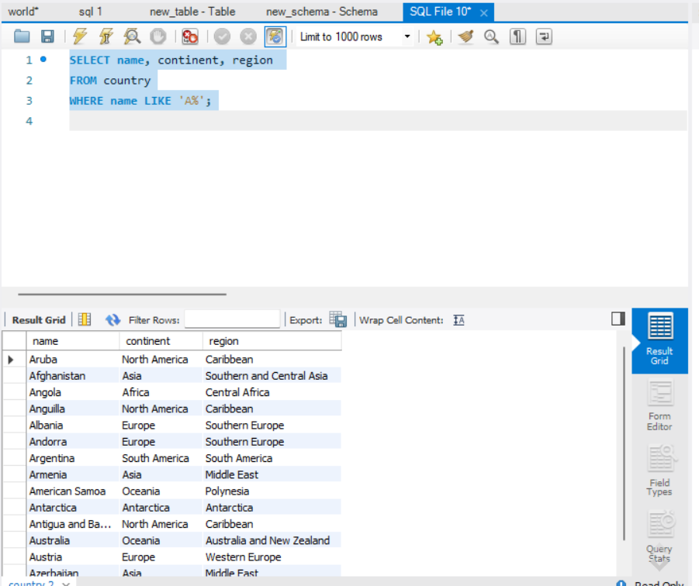

Task 3: Retrieve all the countries that fall under Asia Continent'.

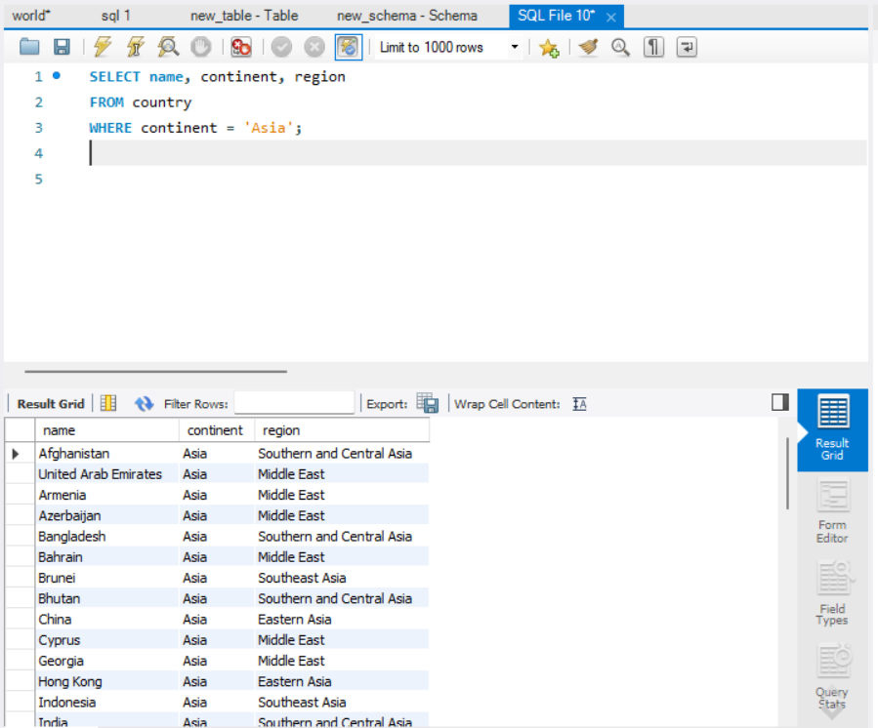

**Task 4:** Retrieve all regions who have life expectancy greater than 80%.

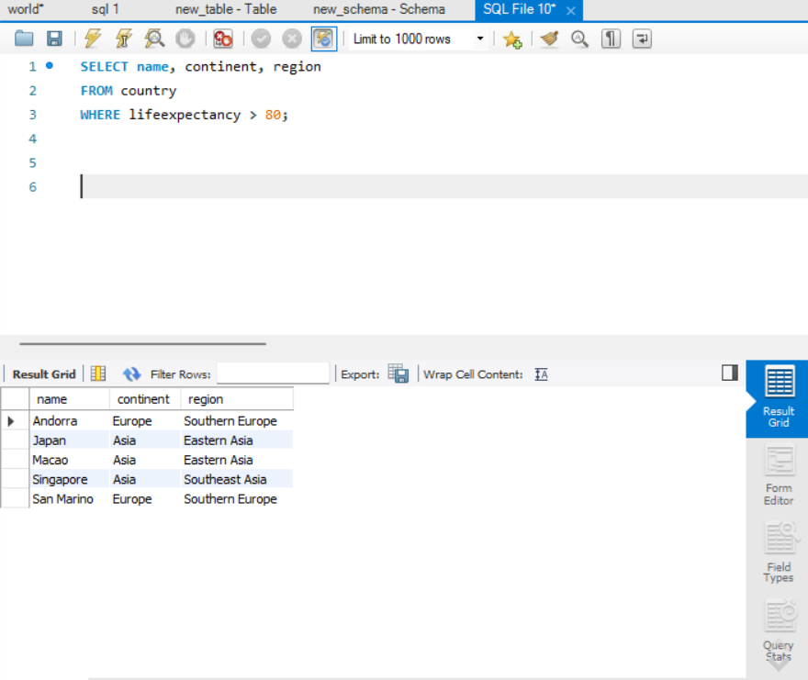

**Task 5:** Find the distinct population in the city table.

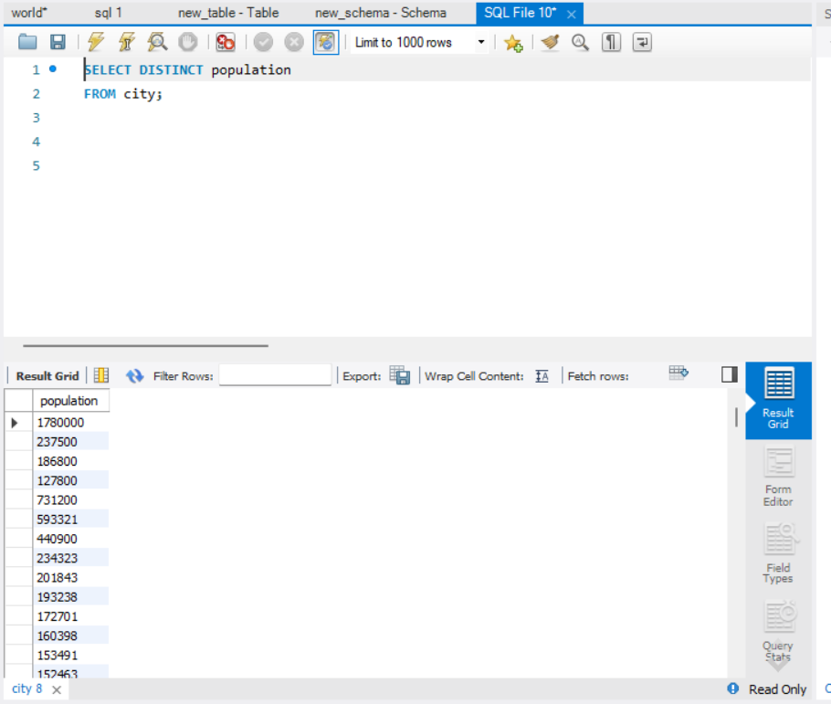

**Task 6:** Retrieve first ten country languages.

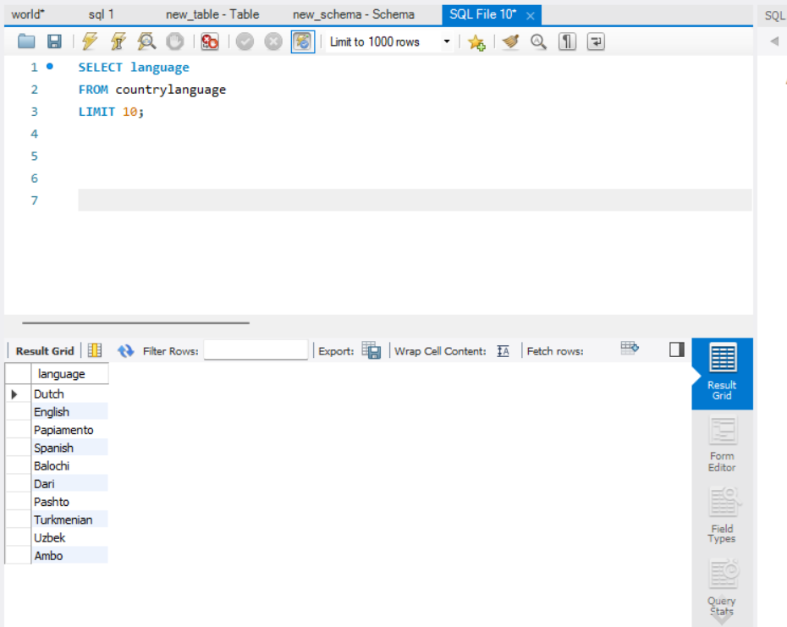

**Task 7:** Display the countries that start with the alphabet a.

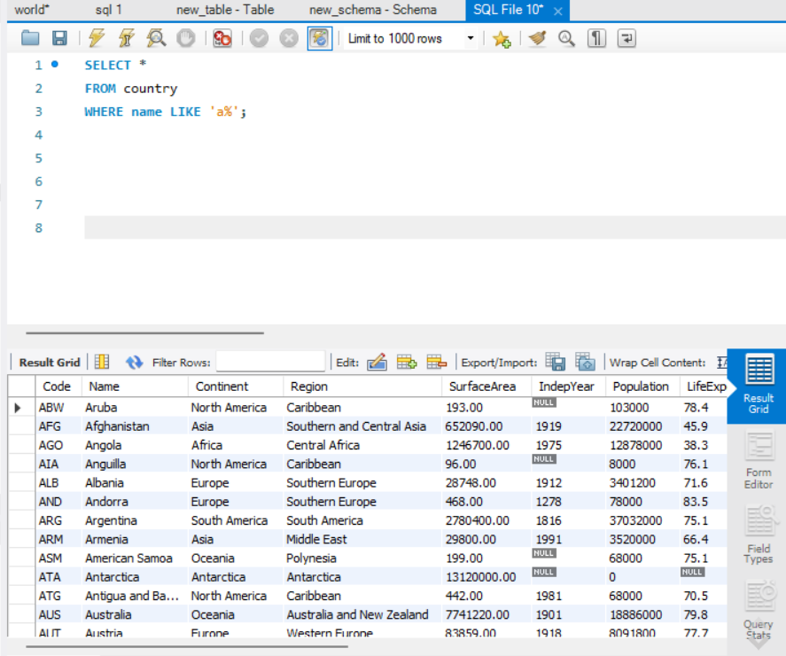

**Task 8:** Retrieve all the countries whose government is republic type and US Territory.

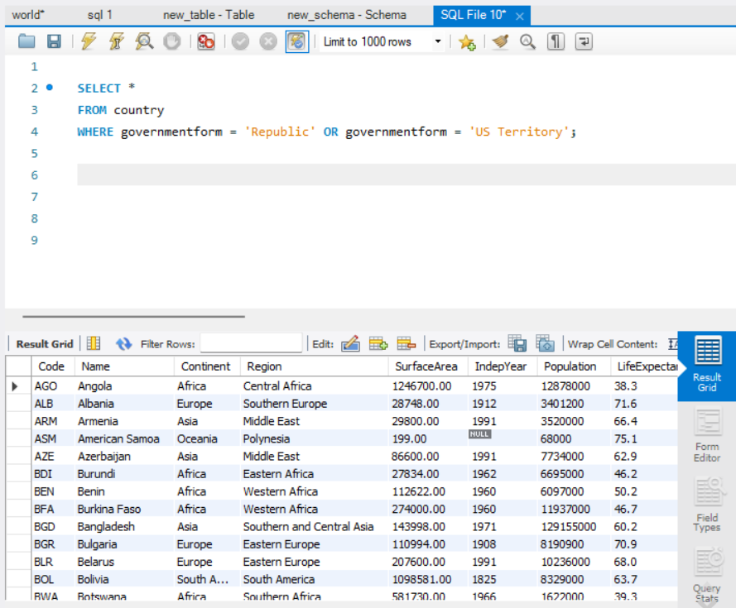

**Task 9:** Retrieve the cities with IDs 1, 5, and 9.

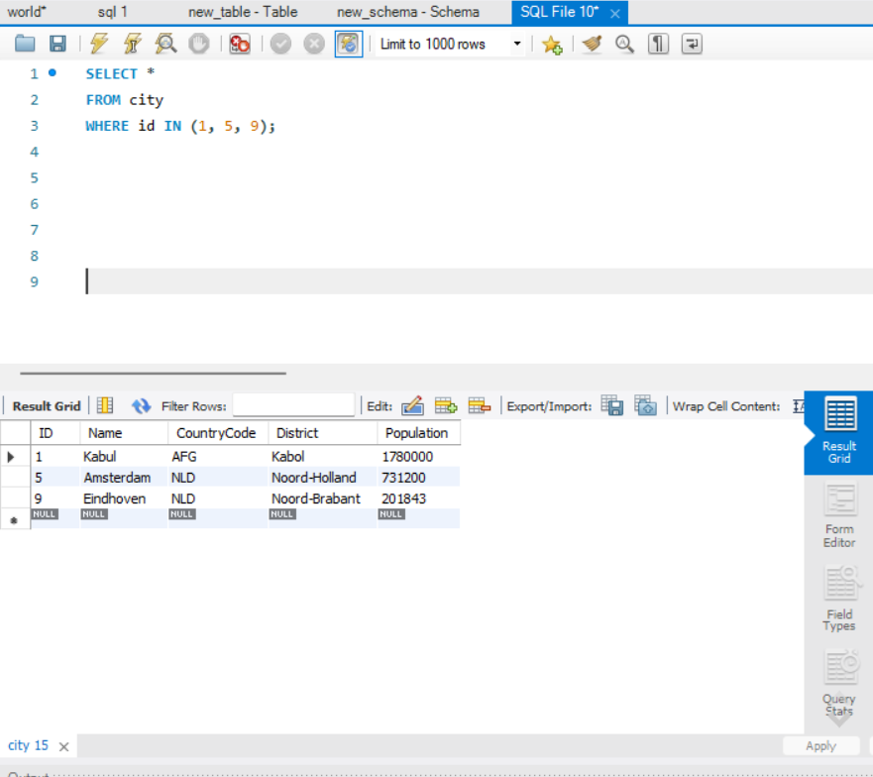

**Task 10:** Retrieve all countries whose speaking language is English.

